**Experiment 2**

**Date:** 24-12-2020

**Aim:** To explore file and directory related commands.

**Software Used:** Cgywin64 Terminal.

**Theory:**

1. **cd:** cd command is known as change directory command. It is used to change the current working directory.

**Syntax:** cd <name of the file/ commands/options>

**Note:** Some symbols used in the form of command/options are:

* **~ :** Specifies the location of your home directory.
* **.. :** Specifies the location of the parent directory.

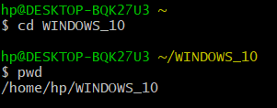

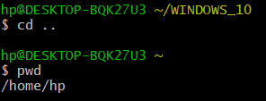

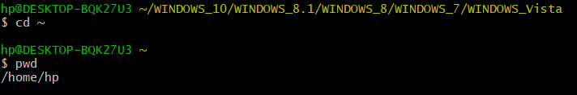

1. **ls:** ls command is used to list the files in the current directory use.

**Syntax**: ls <options> or ls

**Note:**

* + - Options used in ls command are:
      * **-l:** uses a long list format.
      * **-t:** sort by modification time, newest first.
      * **-r, --reverse:** reverse the order while sorting.
      * **-R, --recursive:** list subdirectories recursively.
      * **-i, --inode:** print the index number of each file.
      * **\* :** can be used as a wildcard in UNIX/LINUX.
    - Options can be combined: ls -ltr.
    - **For Example:**
      * **ls- lt:** list the files in time in reverse order with long.

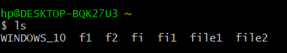

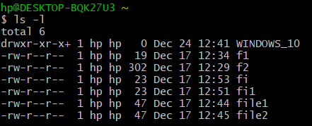

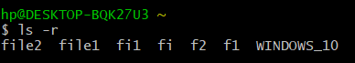



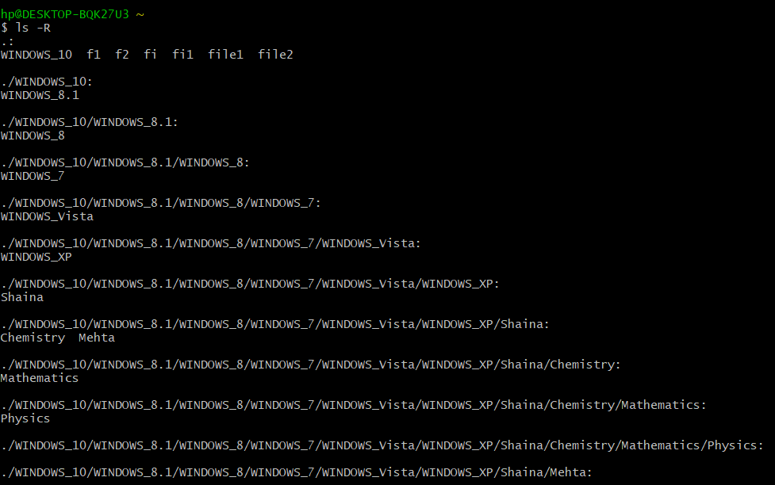

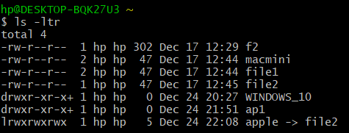

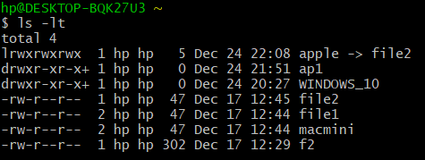

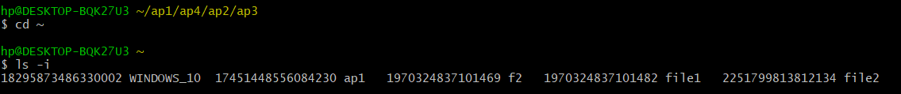

1. **mkdir:** mkdir command is used to create a new directory.

**Syntax:** mkdir <option> <directory> or mkdir <directory>

**Note:**

* The command takes more than one directory name as its arguments.
* Options used in mkdir command are:
  + - * + **-m, --mode:** to set a file mode.
        + **-p, -parents:** no error if existing, otherwise make parent directory as needed.
        + **-v, --verbose:** print the message for each created directory.
        + **-z:** set SELinux security context for each created directory to the default type.
        + **context [=CTX]:** like -z, or if CTX is specified then set the SELinux or

SMACK security to CTX.

* + - * + **--help:** display the help and exit.
        + **--version:** output version information and exit.



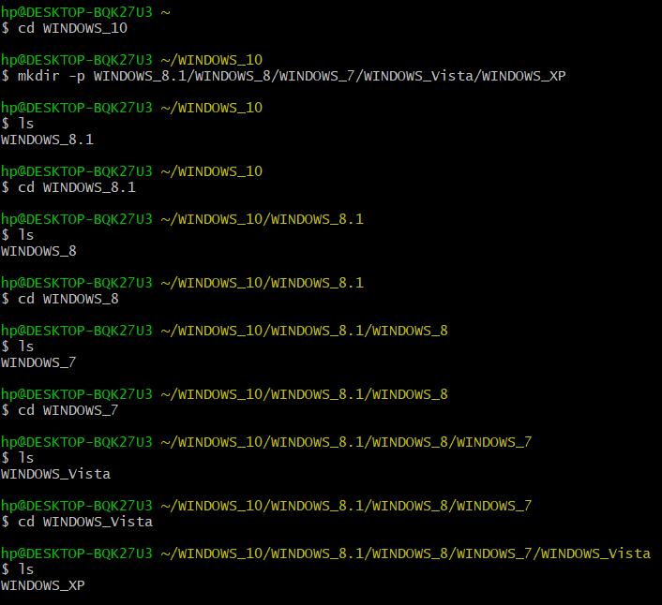

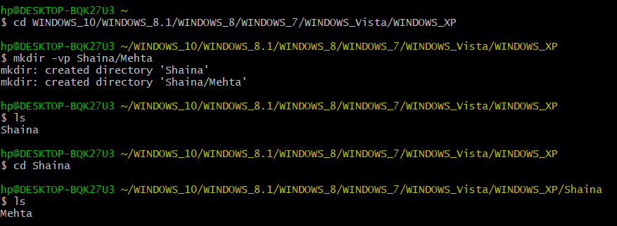

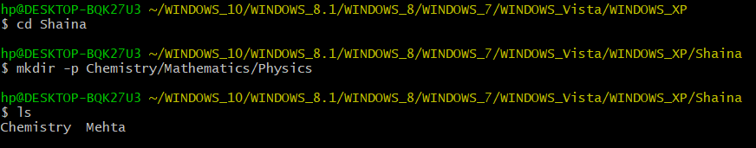

1. **rmdir:** rmdir command is used to remove empty directories.

**Syntax:** rmdir <option> <directory> or rmdir <option>

**Note:** Options used in rmdir are:

* **--ignore-fail-on-non-empty:** ignore each failure that is solely because a directory is non - empty.
* **-p, --parents:** remove directory and its ancestors. For example:  
  ‘rmdir -p a/b/c’ is similar to ‘a/b/c a/b a’.
* **-v, -verbose:** outputs a diagnostic for every directory processed
* **--help:** displays the help and exit.
* **--version:** outputs the version information and exit.

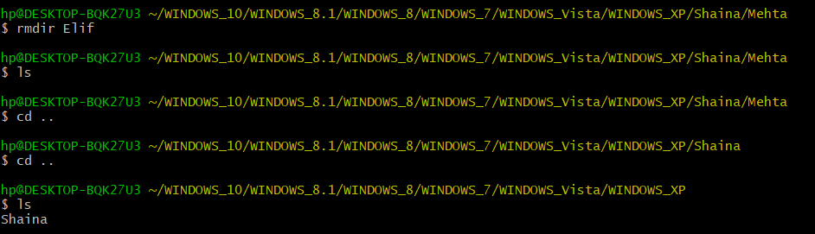

1. **rm:** rm command is used to remove a file.

**Syntax:** rm <directory> or rm <options> <directory>

**Note:** Options used in rm command are:

* **-f, --force:** ignore non existing files and arguments and never prompt.
* **-i:** prompt before every removal.
* **-I:** prompt once before removing more than one files, or when removing recursively; less intuitive than -i, while still giving protection against more mistakes.
* **--interactive [=WHEN]:** prompt according to WHEN: never, once (-I), or always (-i); without WHEN, prompt always.
* **--one – file - system:** when removing the hierarchy recursively, skip any directory that is on the file system different from that corresponding command line argument.
* **--no - preserve – root:** do not treat ‘/’ specially.
* **--preserve – root:** do not remove ‘/’ (default).
* **-r, -R, --recursive:** remove directories and their contents recursively.
* **-d, --dir:** remove empty directories.
* **-v, -verbose:** explain what is being done.
* **--help:** display this help and exit.
* **--version:** output version information and exit.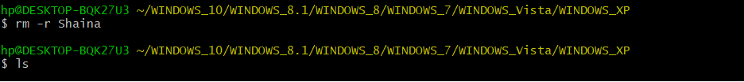

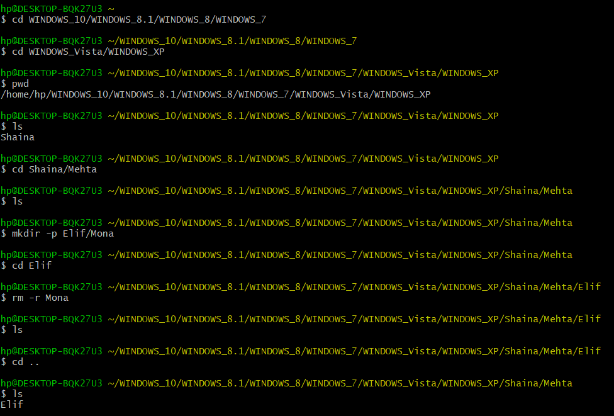

1. **cp:** cp command is used to copy the files or group of files or directories.

**Syntax:**

* cp <source file> <destination file>:copy the contents of one file to another.
* cp <file1> <file2> <directory name>: copy multiple files in a directory.
* cp -i <source file> <destination file>: asks the user whether to copy the source file to the destination file or not.

**Note:**

* By default, the cp command will not copy directories. Attempting to copy a directory results in an error.
* To copy a directory, pass the -R or -r or –recursive flag. This will recursively copy a folder and create a copy.
* **Syntax:** Cp –r <source directory> <destination directory>

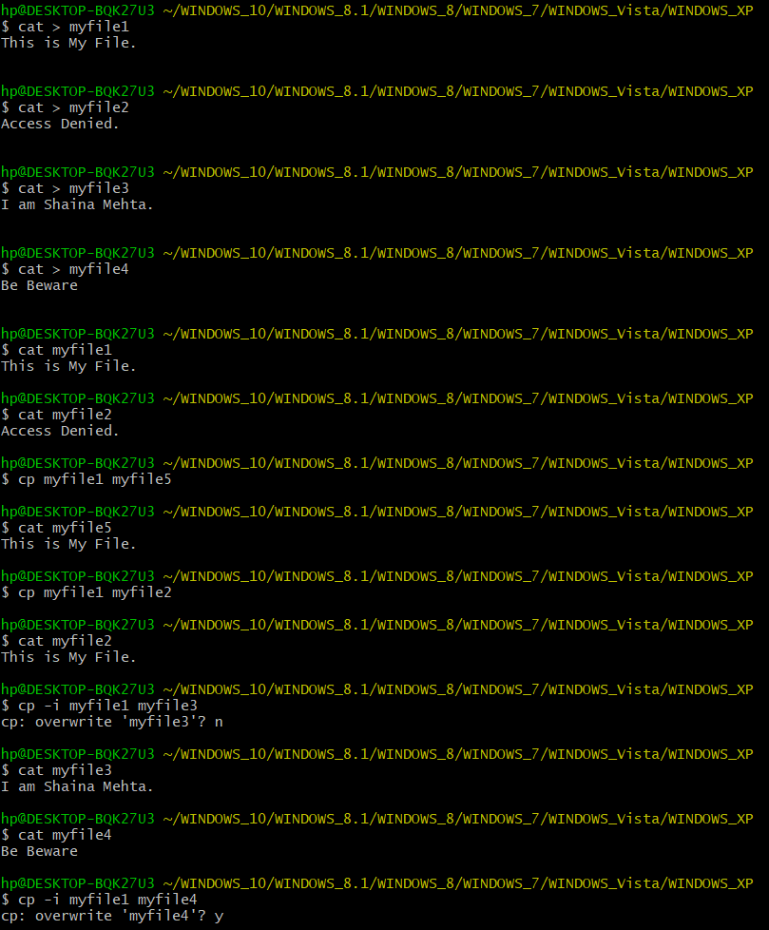



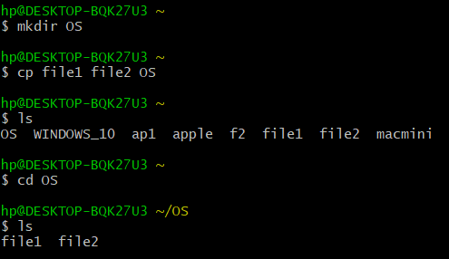

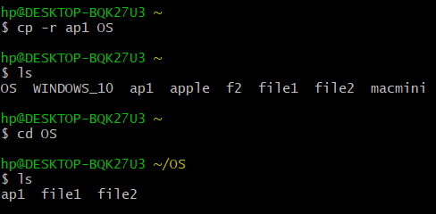

1. **mv:** mv command is used to move files or directories from one place to another.

**Syntax:**

* mv <old file> <new file>:
  + - * + To move a file using the mv command pass the name of the file and then the new name for the file
        + **For Example:** mv file1 file2
        + In above example file1 is renamed to file2.
* mv <old directory> <new directory>: to move a directory.
* mv <file name> <directory name> or mv <file name> <directory name/ filename>: to move a file in a directory.
* mv <file1> <file2> <file3> <directory name>: to move multiple in a given directory.
* mv -I file1 file2: prompt before overwriting a file.

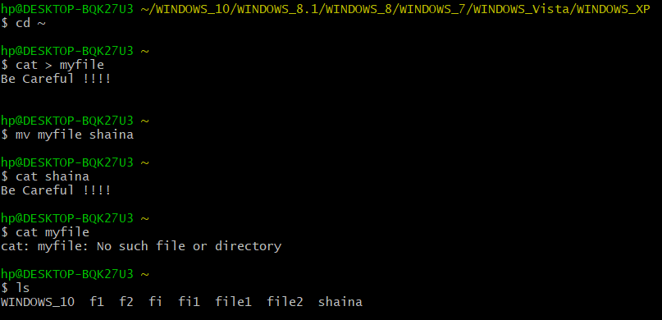

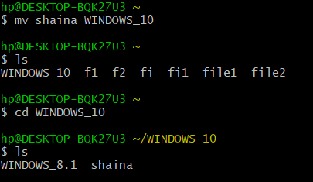

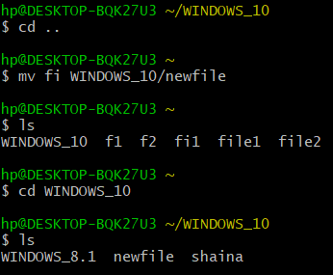

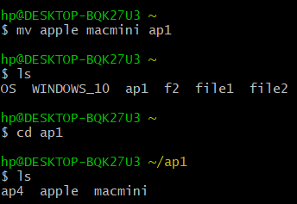

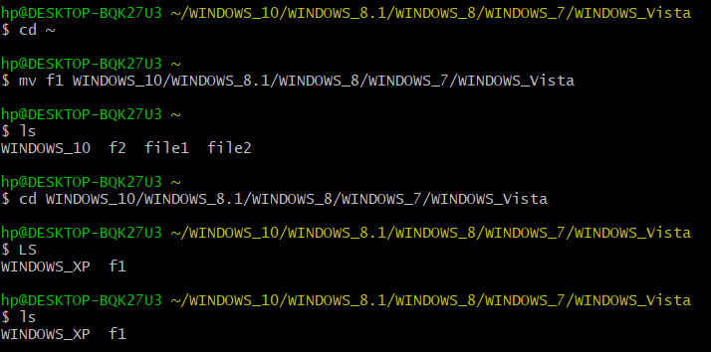

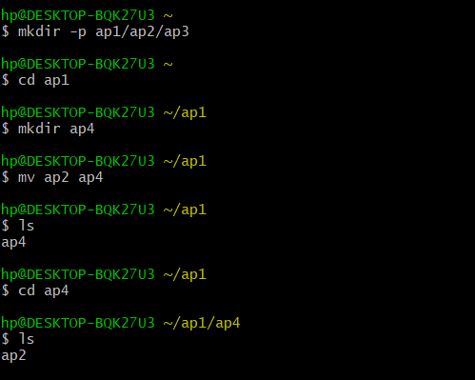

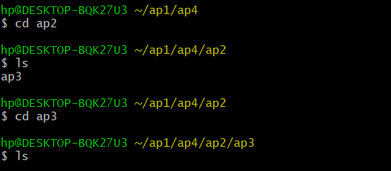

1. **ln:** ln command is used to create links between files.

* **Soft Link:** ln –s filename soft_link name. -s makes symbolic links instead of hard link.

**Syntax:** ln -s <file1> <file2>

* **Hard link:** ln filename hard_link name.

**Syntax:** ln <file1> <file2>

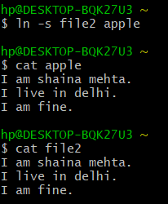

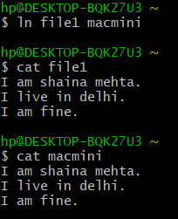

**Result:** Various file and directory related commands has been explored and executed successfully.